Homepage buttons:  
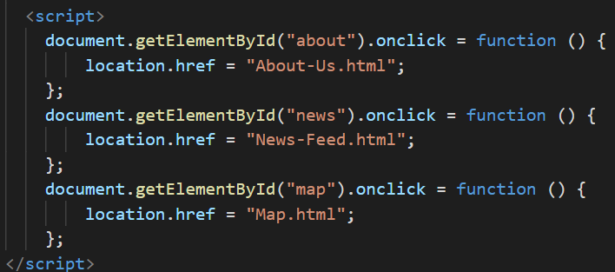onclick function by getting the id of the button

Hover table:

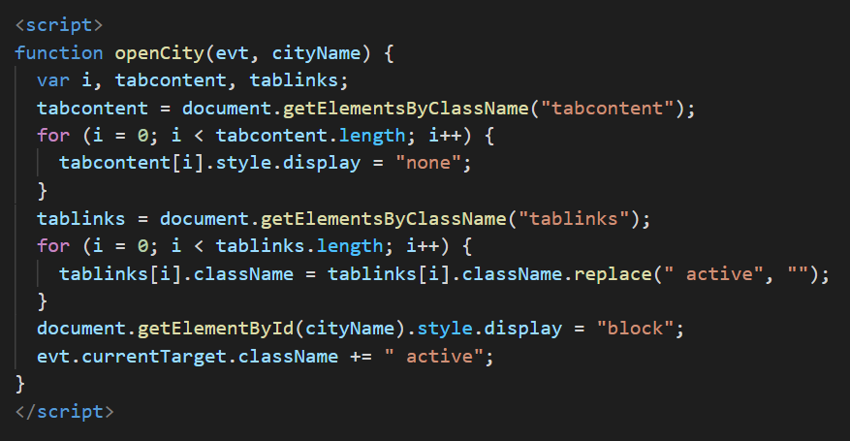

Create buttons to open the specific tab content. All <div> elements with class="tabcontent" are hidden by default (with CSS & JS) - when the user move the mouse over a button - it will open the tab content that "matches" this button.

Get all elements with class="tabcontent" and hide them

Get all elements with class="tablinks" and remove the class "active"

Show the current tab, and add an "active" class to the link that opened the tab

Dark mode:

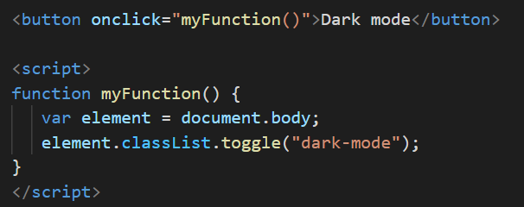

Get the <body> element and toggle between the .dark-mode class

Switch between dark and light mode with CSS and JavaScript.

Top button:

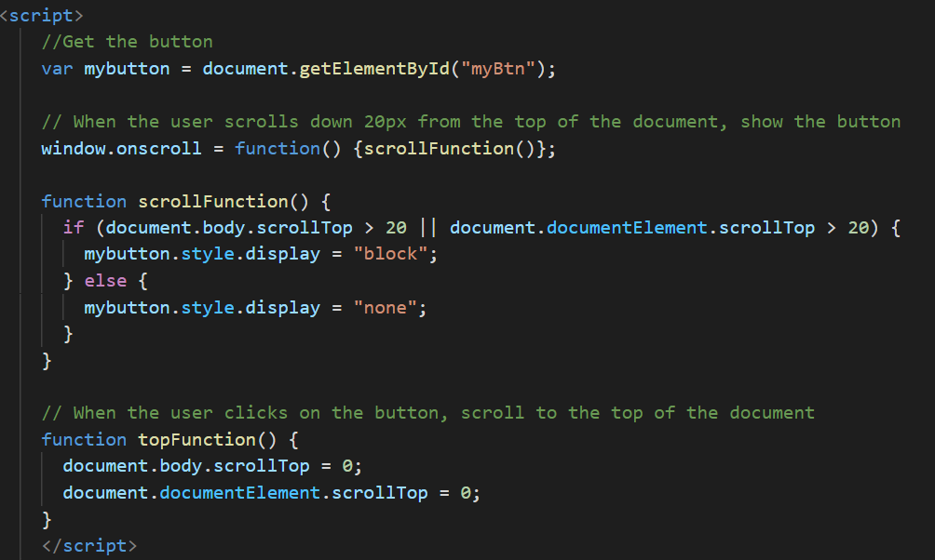

Create a button that will take the user to the top of the page when clicked on

When the user scrolls down 20px from the top of the document, show the button

When the user clicks on the button, scroll to the top of the document

Slideshow:

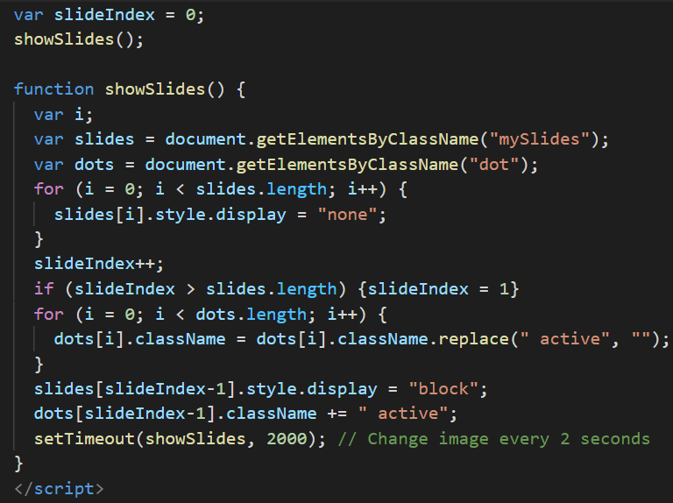

A slideshow is used to cycle through elements

Automatic slideshow